Module 4 Written Report

Based on the data shown on the local schools' budgets, type, and reading & math scores, it is clear that the budget spent per student does not have a significant impact on the students' academic well-being. All schools fell within the range of over $550 to under $660 per student, regardless of whether they were top overall performers or bottom performers.

However, it is evident that independent schools are more likely to achieve better academic performance compared to government schools. This observation is supported by the Scores by School Type data, which indicates that independent schools have higher average scores and passing rates for both subjects when compared to government schools.

Furthermore, the Scores by School Size data reveals an important trend: larger schools tend to have lower average scores and passing percentages for all subjects. This suggests that as the number of students increases, there is less individual attention and resources available for each student, even when the budget per student is similar to that of smaller schools.

I believe that this disparity between the higher passing rates in independent schools and lower passing rates in government schools can be attributed to the fact that government schools have a significantly larger student population. Consequently, there is less time and fewer resources allocated to each student compared to independent schools.

Local Government Area Summary

School Summary

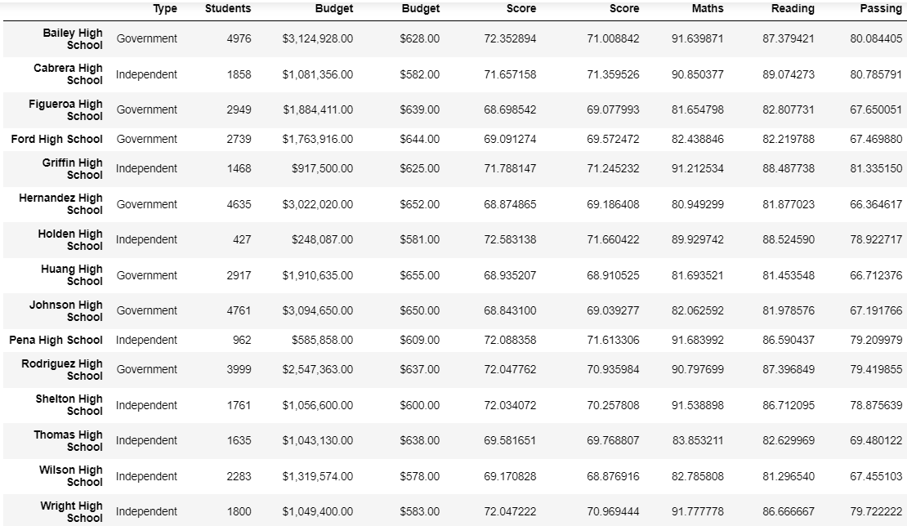

Top 5 Performing Schools (By % Overall Passing)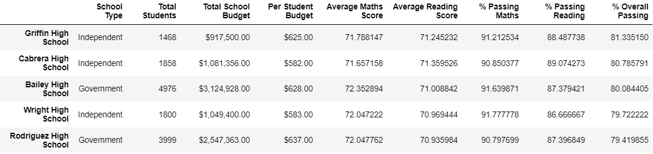

Bottom 5 Performing Schools (By % Overall Passing)

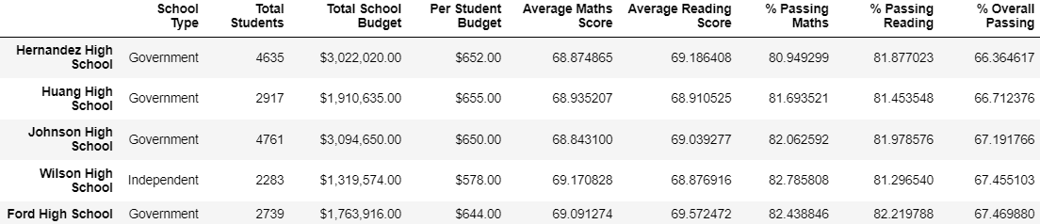

Maths Scores by Year

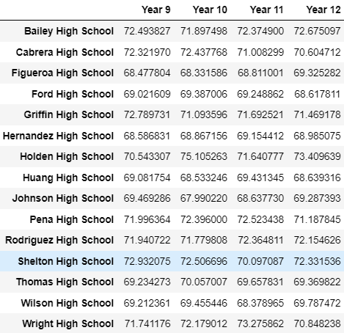

Reading Score by Year

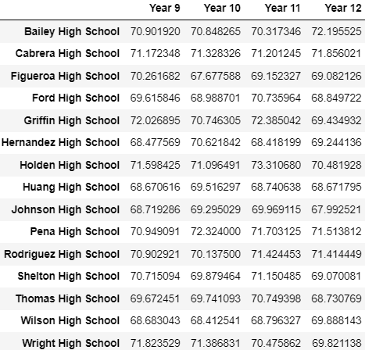

Scores by School Spending

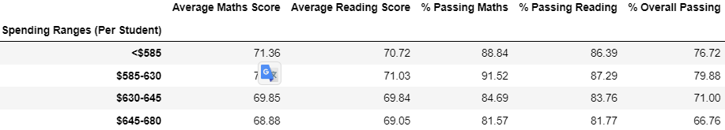

Scores by School Size

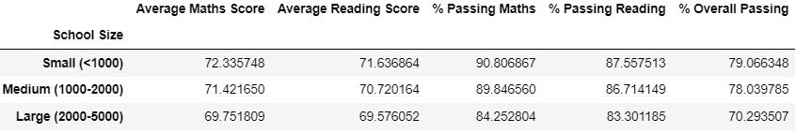

Scores by School Type

